Experiment 8: reading experiment of analog value
In this experiment we began to learn about the use of I / O interface simulation, Arduino has analog 0 simulated 5 a total of six analog interface, the interface can also count as the reuse of interface functions, in addition to simulate the function of the interface, the interface can be used as a digital interface, the code for digital 14 - 19 the number, simple understanding, below to start our experiment. Potentiometer is we are more familiar with the typical analog value output element, this study is use it to complete.
Required components ：
Potentiometer *1
Bread board *1
Bread board jumper *1 tie
In this experiment we will the resistance value of the potentiometer transformation is an analog value is read out, and then show examples of application to the screen, and this is our after the completion of the required experimental functions must master。
We must first follow the following circuit diagram attached to the physical map：
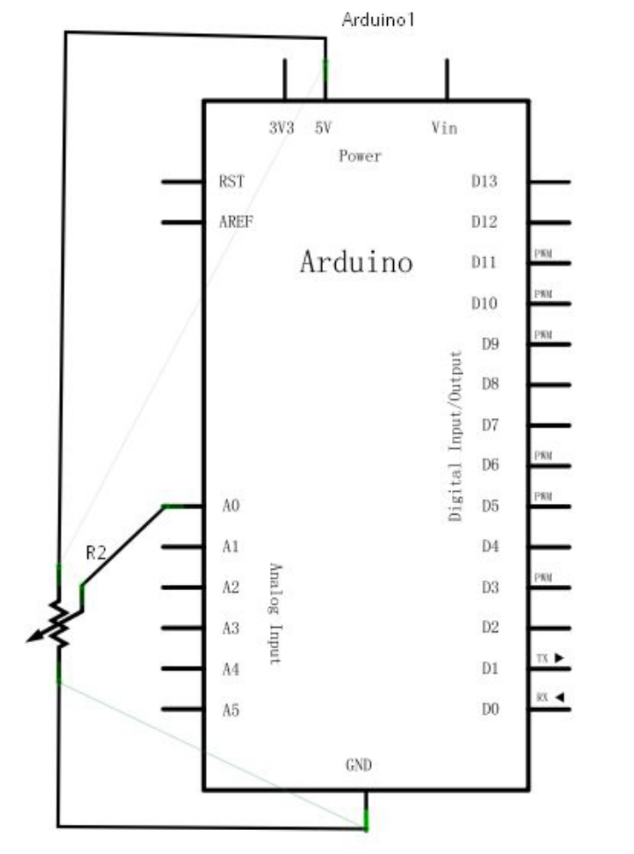
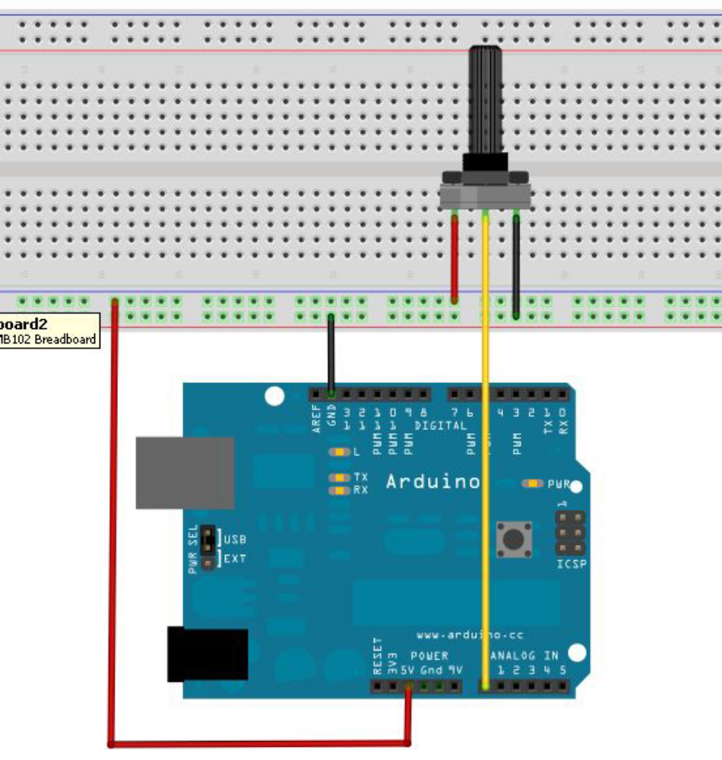
We use a simulation of the 0 interface.
Programming is also very simple, a analogRead (), the statement can read the value of the analog port, Arduino 10 is the 328 bit A/D acquisition, so read the range of analog values is 0-1023, the program has a difficult point is to display the value of this problem in the screen, the study is also very simple.First of all, we must in voidsetup () set baud rate, showing number belongs to the Arduino and PC communication, so the baud rate of the Arduino should be set with PC software can show the correct value, otherwise it will be garbled or is not displayed, in the Arduino software monitor window in the lower right corner of a button you can set the baud rate, here to set the baud rate need to program void setup() set the baud rate of the same.The program to set the baud rate statement is Serial.begin (a);

No. for baud rate value. Secondly is to display the numerical statement, Serial.print (), or Serial.println (); can be, different is the end value automatically enter, not the former, more about the statement explain in front of Introduced here is no longer to say.
The following is a reference to source program:
int potpin=0;//Define analog interface 0
int ledpin=13;//Define analog interface13
int val=0;//Will define the variable Val, and assign the initial value of 0

void setup()
{
pinMode(ledpin,OUTPUT);//Define digital interface as output interface
Serial.begin(9600);//Set the baud rate to 9600
}
void loop()
{
digitalWrite(ledpin,HIGH);//Light digital interface 13 LED
delay(50);//delay 0.05scs
digitalWrite(ledpin,LOW);//Extinguishing digital interface 13 LED
delay(50);//delay 0.05scs
val=analogRead(potpin);//Read the value of the analog interface 0, and assign it to the val
Serial.println(val);//Shows the value of Val
}
The reference program uses Arduino digital 13 built-in LED lights, each time value will lights flash once.
The analog values are read out below.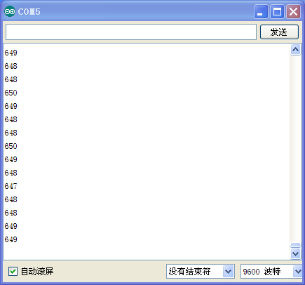
Experimental phenomenon: when you rotate the potentiometer knob can see numerical changes on a screen, read analog value this method will always accompany us. The simulation results read is we very commonly used functions, because a lot of sensor is analog value output, we have read analog values and the corresponding algorithm to deal with, it can be applied to we need to implement the function of the.
This experiment is done here, thank you.

